**EE533: Network Processor Design & Programming**

**Lab #4: NetFPGA BitFile Generation and Using NetFPGA**

Instructor: Prof. Young Cho, PhD

Team Number:**#3**

***Project Partners:***

*Member #1:* **Sarthak Jain**

*Member #2:* **Archit Sethi**

*Member #3:* **Justin Santos**

*Designed, Created, and Submitted by Team #3*

***University of Southern California***

***Los Angeles, CA 90007***

Team #4 GitHub Repository Link: [*Team#3 Link*](https://github.com/EE533-TEAM3/EE533_LAB_PROJECTS/tree/main/LAB4)

**Part-1: Download and Set-Up NetFPGA Tool Virtual Machine**

1. Virtual Machine Fedora 14 was successfully downloaded and installed on the VirtualBox software.
2. In the terminal, enter ‘su’ to switch into root user to compile the design into a bitfile.

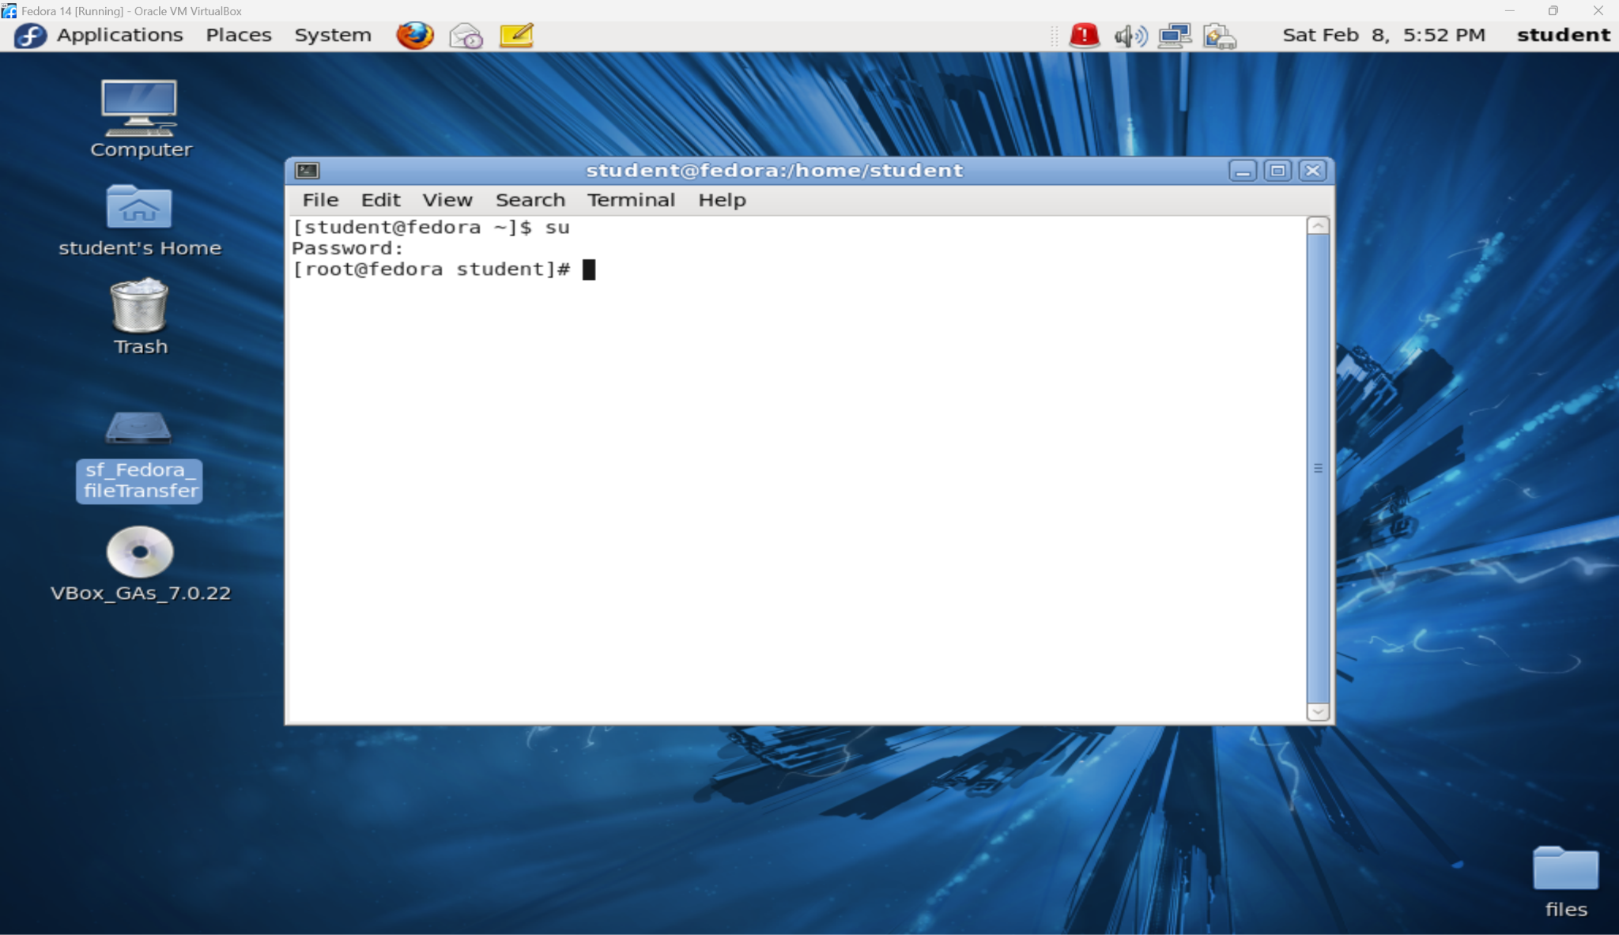

1. Change directory into the NetFPGA projects directory with ‘cd’ command.

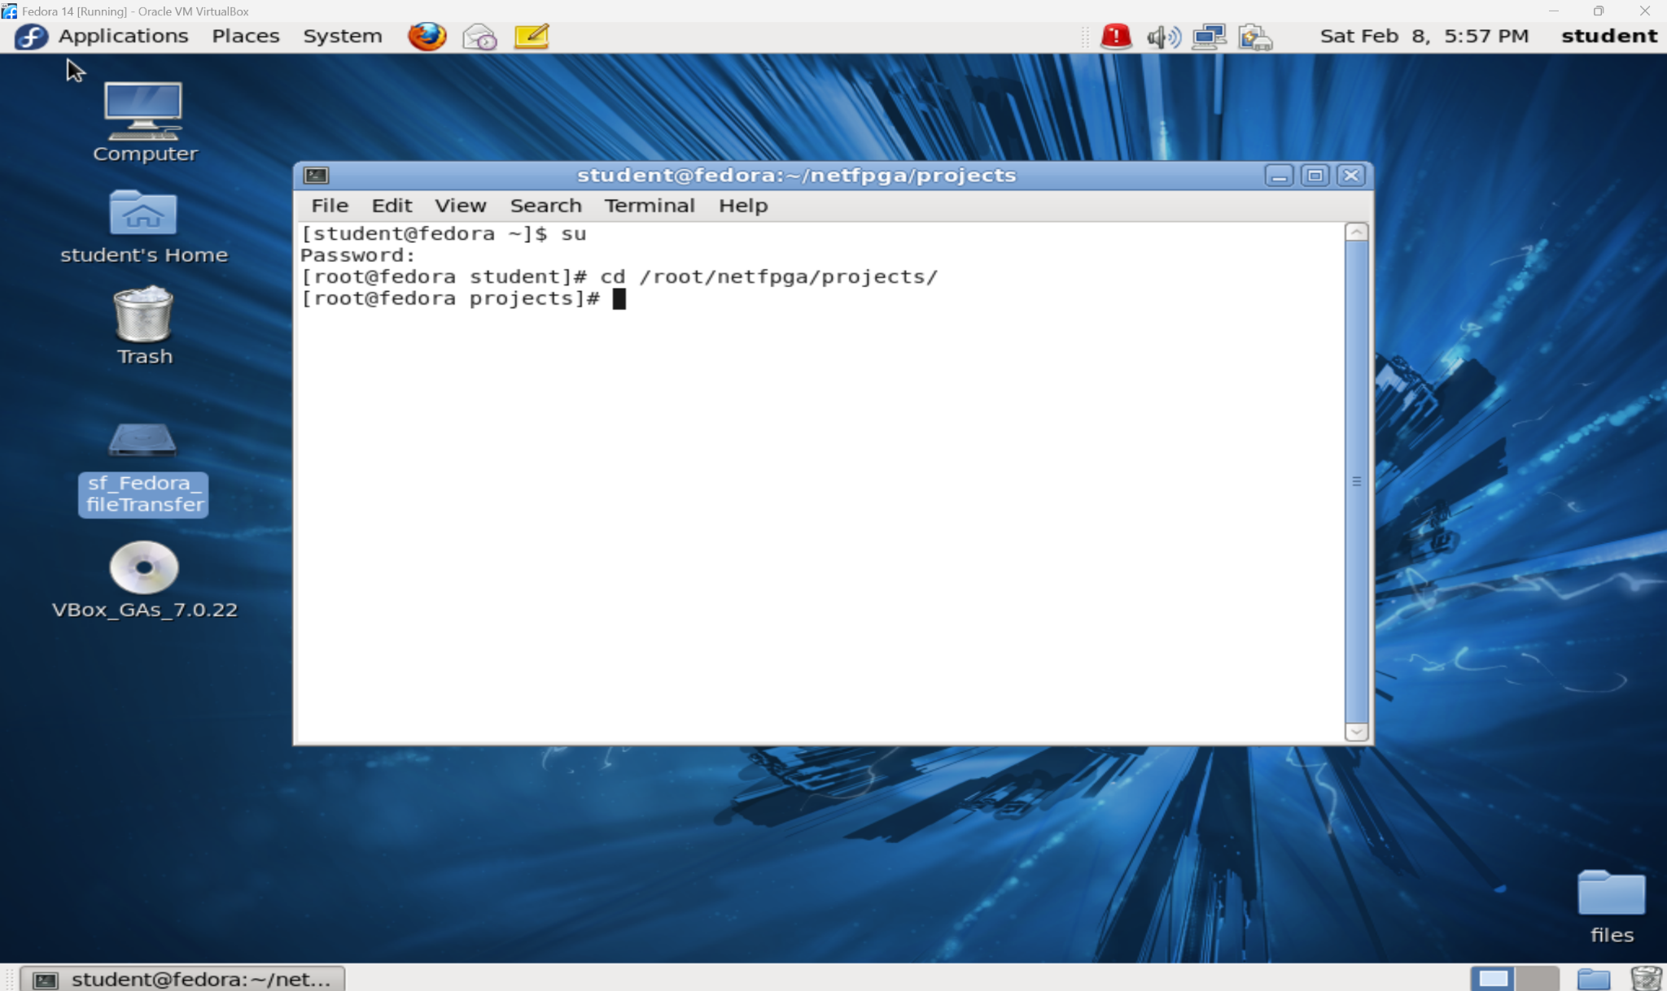

1. Copy the reference_router project into your project folder with ‘cp’ command

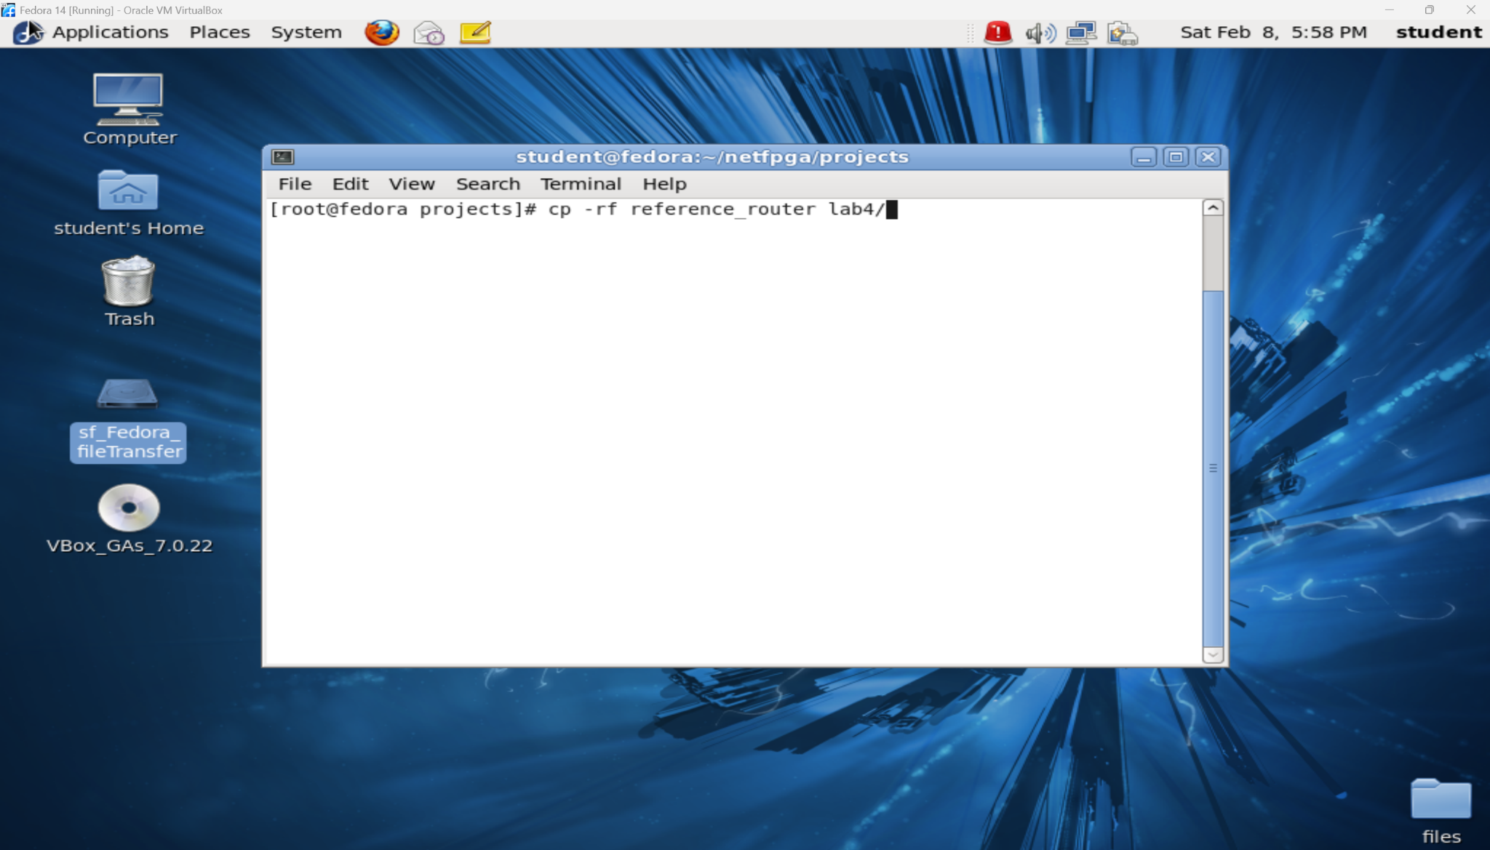

1. Change directory into a synthesis folder into your project with ‘cd’ command

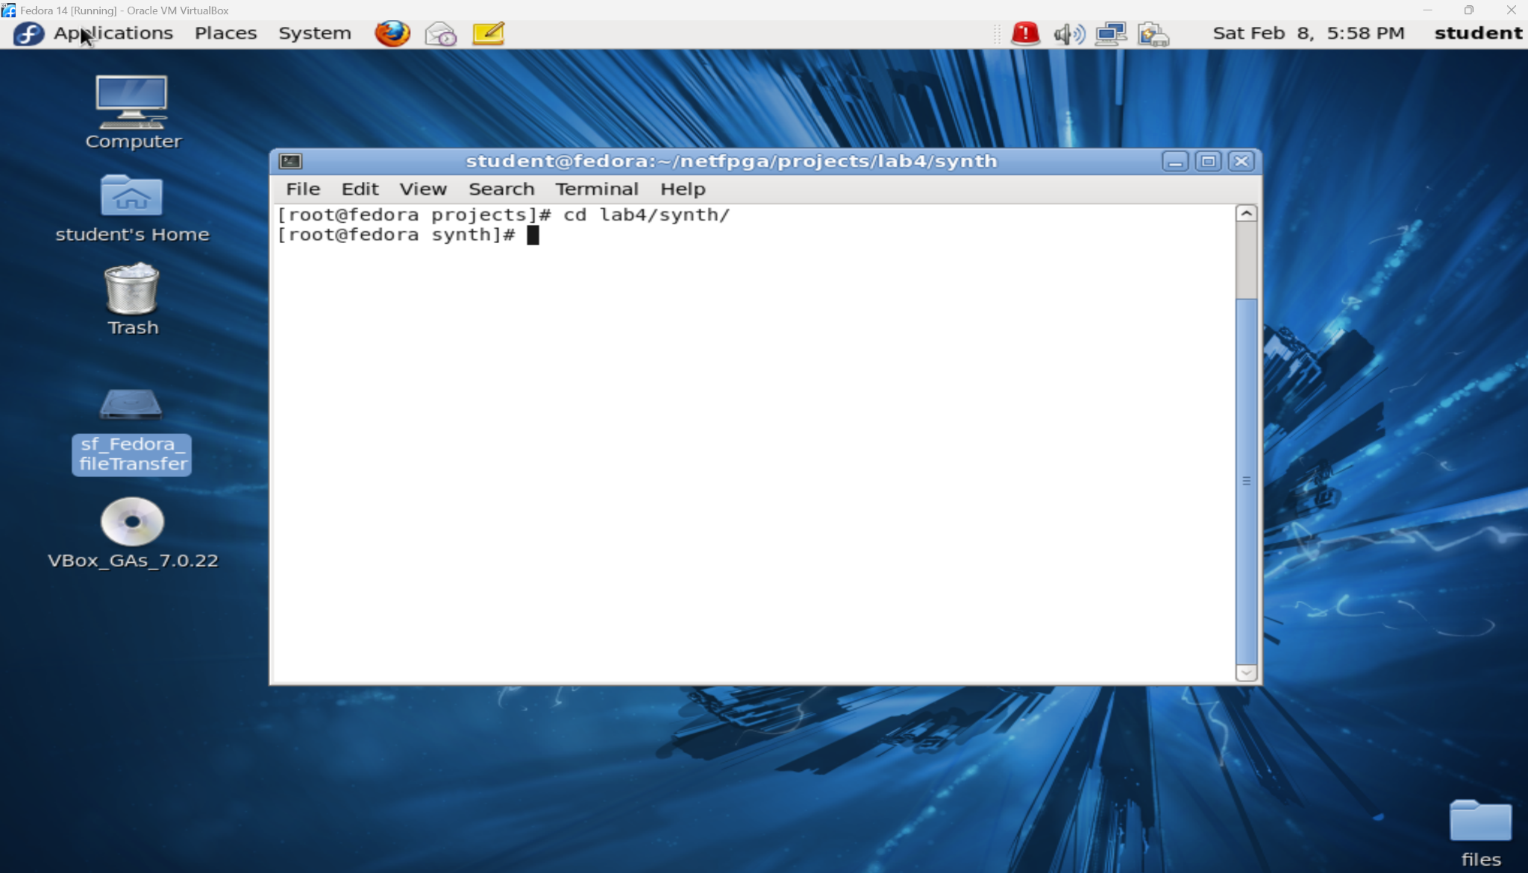

1. Compile the design by typing ‘make’

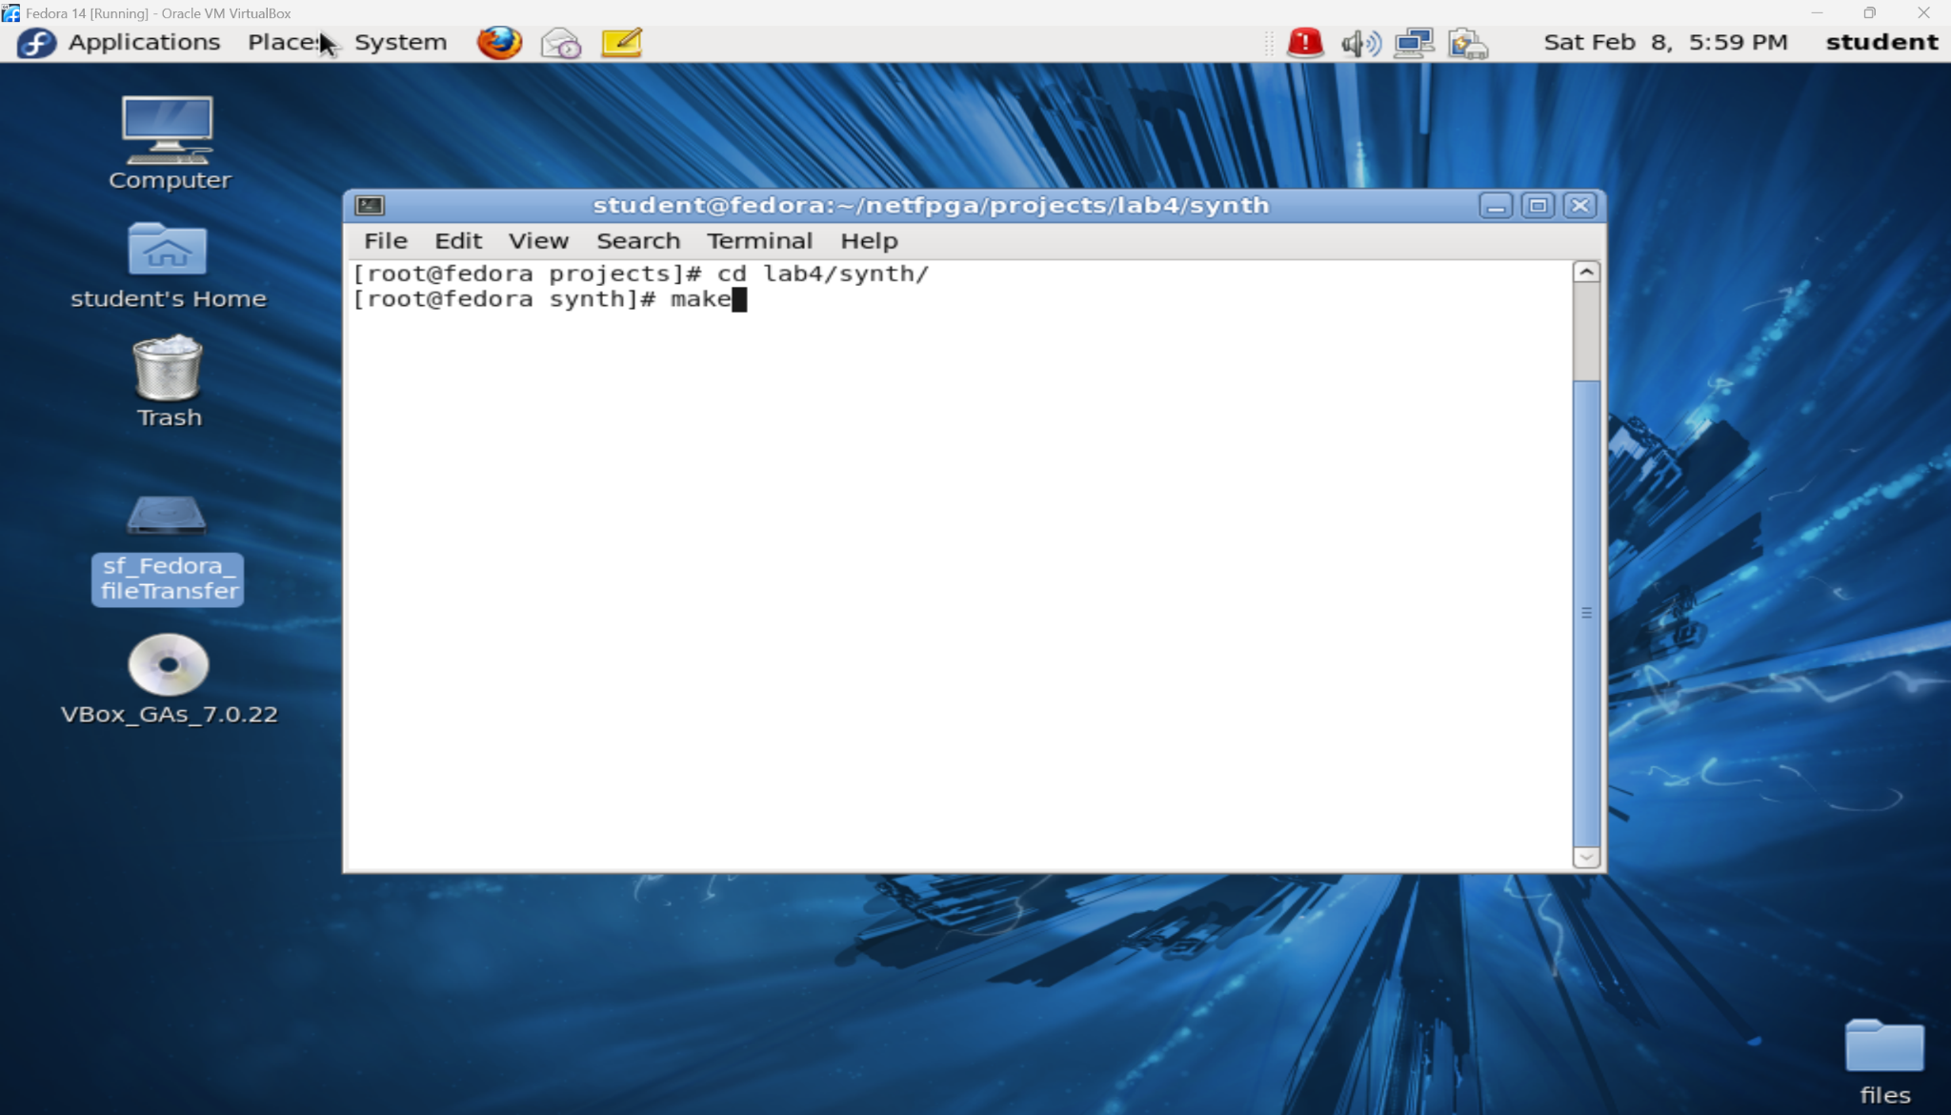

1. This should start the compilation and generation of a bit-file for your reference_router project

The command ‘make’ was running and we found that there were many errors from the imported schematics from the previous lab-3. The debugging was a tedious process but was handled with efficiency.

**Part-2: Compile and generate a design bitfile for NetFPGA**

1. Converting schematics to verilog code as it was demonstrated in the following video.
2. After extraction of ‘ids_hw’ from lab-3_mini_ids_src.zip
3. Copied all converted verilog and ip core files into ids_hw/src.
4. This is how the make command ran and we got a few errors which have been depicted further below.

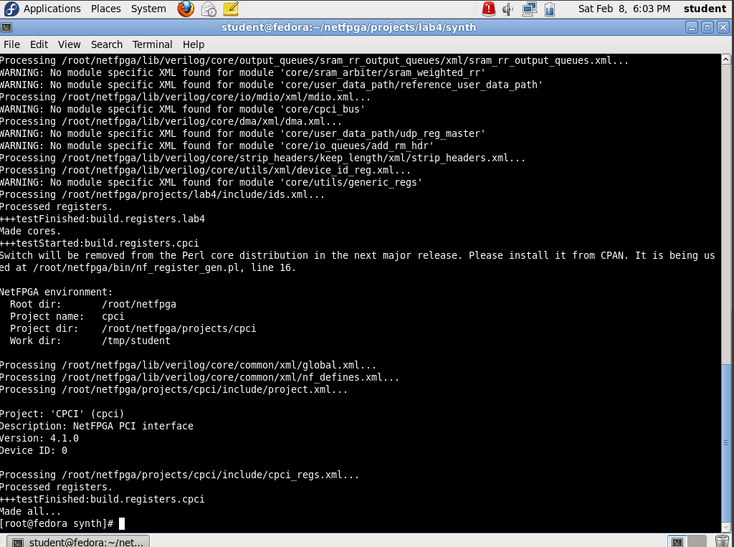

From the figure below, you can clearly see that we were able to successfully generate the bitfile. The mentioned bitfile that was generated was ***‘nf2_top_par.bit’***’



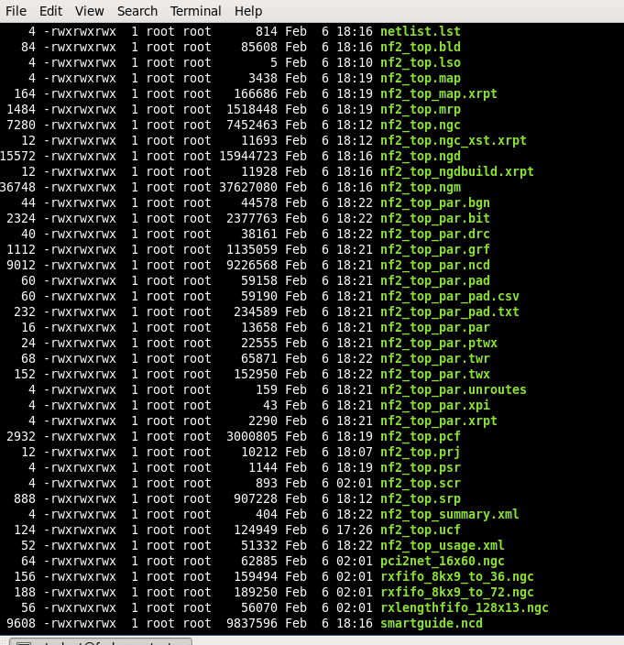

When we used the ‘ls’ command we were able to clearly see our generated bitfile in the lab4/synth/folder. See the snippet below for details.  
  
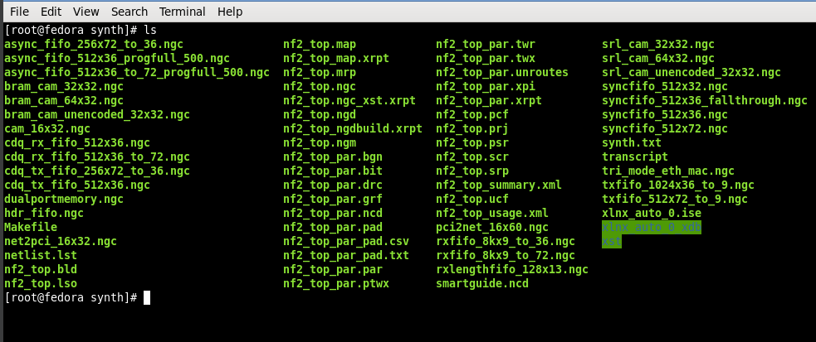

We also took screenshots of a few errors we encountered while running the ‘make’ command.

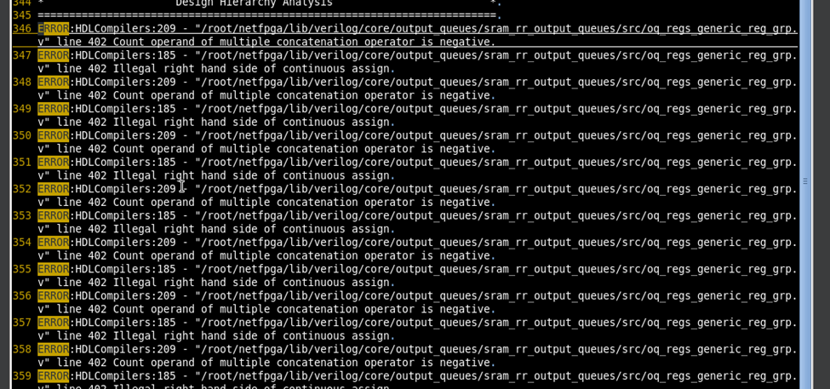  
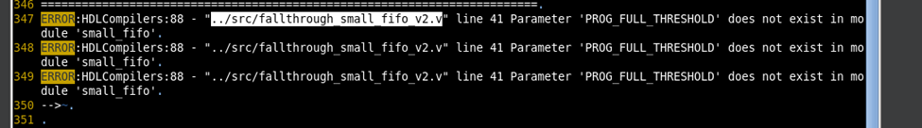

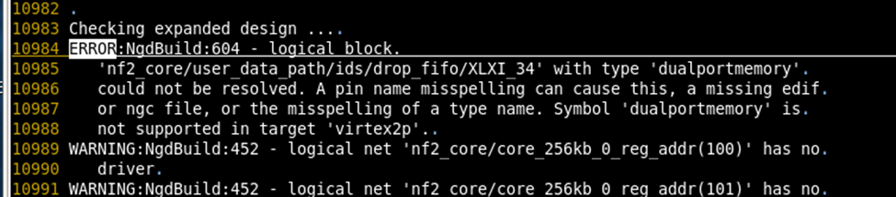

We also are uploading the bitfile generation summary & timing report as a proof of work it took us to debug each of the errors while running the make command.

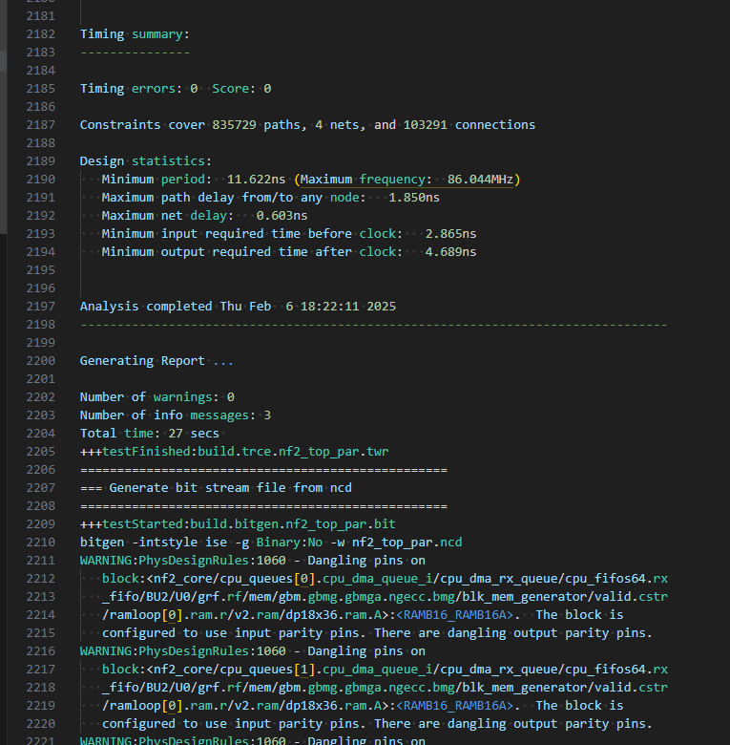

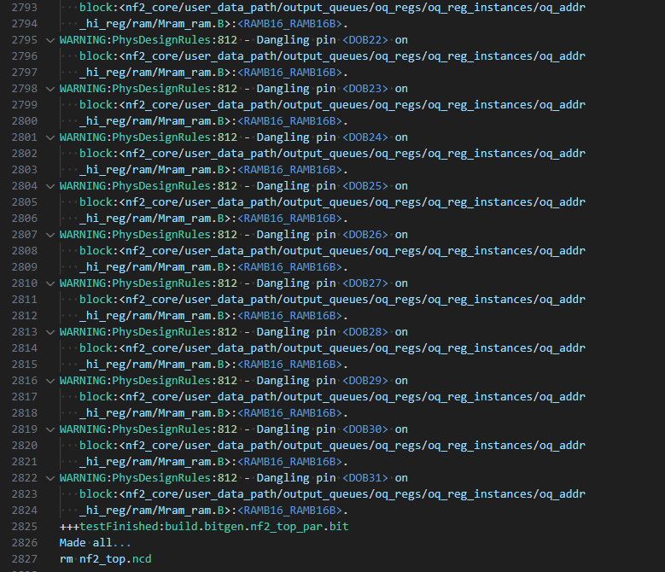

**Part-3: Set Up VPN to USC**

We successfully set up the VPN at *vpn.usc.edu*

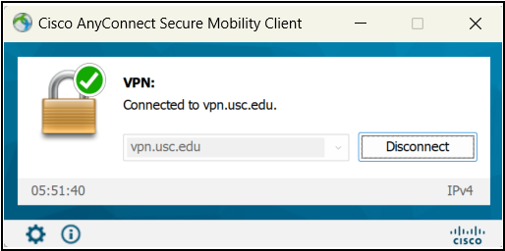

**Part-4: NetFPGA Environment**

1. *Openssh* & *nano* were installed using:  
   *sudo apt-get install openssh-client nano*
2. Ssh client was edited using nano editor:

*sudo nano /etc/ssh/ssh_config*

1. Following text was added:

*HostkeyAlgorithms ssh-dss,ssh-rsa*

*KexAlgorithms +diffie-hellman-group1-sha1*

*StrictHostKeyChecking=accept-new*

1. After creating the executable file and connecting to vpn.

openterm <TEAM #> <TEAM_PASSWORD>

**[NOTE: We are Team#4 but the Team number assigned to us is Team#3]**

As depicted in the following snippet, we were able to execute openterm and launch the NetFPGA node and 4 nodes that are connected to NetFPGA.

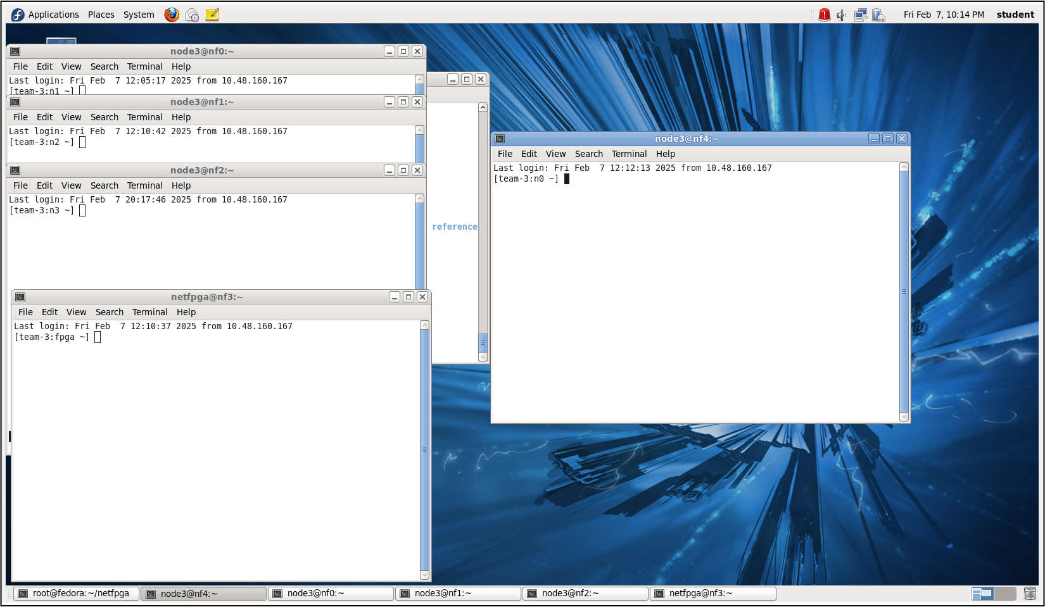

In order to better understand the openterm:

We have added a short explanation for this openterm.

#!/bin/bash

if [ "$#" -le 1 ]; then

echo "$0 <TEAM #> <PASSWD>"

exit 0

fi

if [ "$#" -le 1 ]; then ... fi → Ensures the script receives **at least two Arguments**:

* **$1 (TEAM #)** → A team number.
* **$2 (PASSWD)** → A password for SSH authentication.

**   
ND=$(($1 % 5)) # Compute remainder when TEAM # is divided by 5  
LL=$(($1 + 1)) # Increment TEAM #  
CM=$LL"q;d" # Unused variable (concatenates TEAM + "q;d")  
PW=$2 # Stores the SSH password  
CL=$(( $(($1 / 5)) * 5 )) # Rounds TEAM # down to the nearest multiple of 5  
  
**ND=$(($1 % 5))** → Computes a **node index (0-4)** based on the team number.  
**LL=$(($1 + 1))** → Adds **1 to the team number** (possibly used for reference).  
**CM=$LL"q;d"** → Seems unused; it creates a string with **team number + "q;d"**.  
**PW=$2** → Stores the **SSH password**.  
**CL=$(( $(($1 / 5)) * 5 ))** → Computes the **nearest multiple of 5** for team number.

**   
M0=$(($ND + $CL))  
M1=$(( $(( $(($ND + 1)) % 5)) + $CL))  
M2=$(( $(( $(($ND + 2)) % 5)) + $CL))  
M3=$(( $(( $(($ND + 3)) % 5)) + $CL))  
M4=$(( $(( $(($ND + 4)) % 5)) + $CL))

* This calculates **five machine numbers** (M0 - M4) that the script will SSH into.  
* Each **M#** represents a **different machine ID** in a cyclic manner.  
* It ensures the machines are assigned within **groups of five** (CL helps keep machines   
 within the same batch).  
  
**  
**gnome-terminal -- bash -c "sshpass -p $PW ssh -o StrictHostKeyChecking=no netfpga@nf$M0.usc.edu" &**

**gnome-terminal -- bash -c "sshpass -p $PW ssh -o StrictHostKeyChecking=no node$ND@nf$M1.usc.edu" &**

**gnome-terminal -- bash -c "sshpass -p $PW ssh -o StrictHostKeyChecking=no node$ND@nf$M2.usc.edu" &**

**gnome-terminal -- bash -c "sshpass -p $PW ssh -o StrictHostKeyChecking=no node$ND@nf$M3.usc.edu" &**

**gnome-terminal -- bash -c "sshpass -p $PW ssh -o StrictHostKeyChecking=no node$ND@nf$M4.usc.edu" &**

Opens five separate GNOME terminal windows, each executing an SSH session.

**sshpass -p $PW ssh ... → Uses the given password ($PW) for SSH authentication.**

**-o StrictHostKeyChecking=no → Disables SSH's host key verification prompt.**

**Targets machines:**

* **First SSH login is for netfpga@nf$M0.usc.edu.**
* **The next four logins are for node$ND@nfM1.usc.edu, node$ND@nfM2.usc.edu, etc.**

Each command ends with &, which runs it in the background so that all SSH sessions open simultaneously.

**\*\*  
For TEAM # = 3, the script:**

**✅ Computes machine IDs: 3, 4, 0, 1, 2.  
✅ Uses password authentication with sshpass.  
✅ Opens five GNOME terminal windows, each running an SSH session.  
✅ Logs into a mix of netfpga and node3 user accounts on different machines.**

We were also able to find the IP addresses of each node using “echo”.

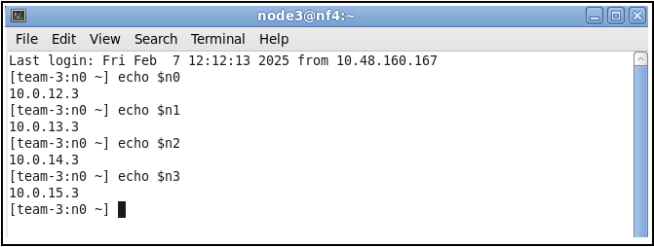

**Part-5: NetFPGA-based Linux Kernel IP Router**

On the FPGA node, we loaded the bitstream of the reference_nic design.

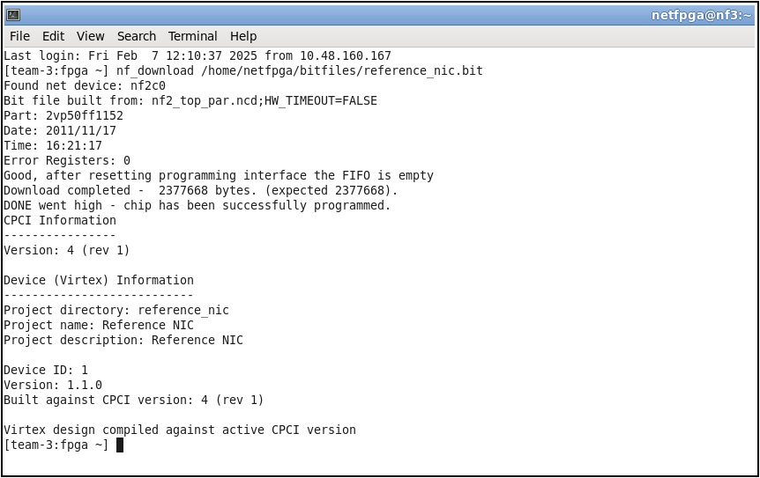

We were also able to ping all nodes from each node. For instance, we were able to ping n3 from n0.

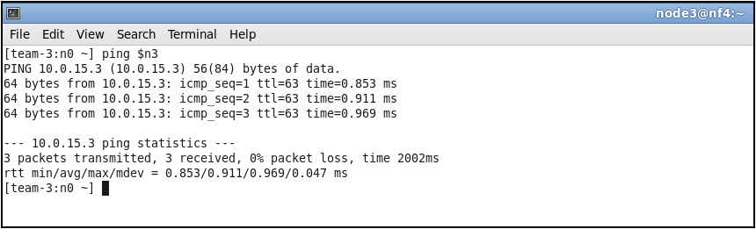

We then executed iperf commands to test the connectivity between nodes. In the following snippet, n2 is the server and n1 is the client. From the snippet, we note that the bandwidth is about 77.8 Mbits/sec.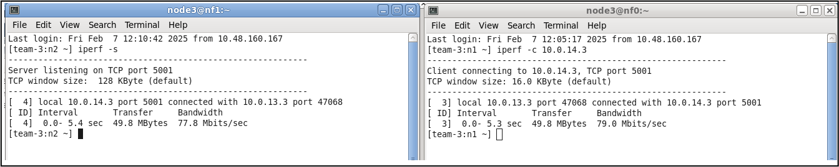

**Part-6: NetFPGA Hardware IP Router**

1. This is the part where the NetFPGA was tested as a hardware IP router.
2. Load the reference router into the NetFPGA. What does the reference router do? How should this help?

*ANS:* The reference router extracts all the information from the Linux Kernel to the routing table of the NetFPGA. This is done to accelerate the routing process.

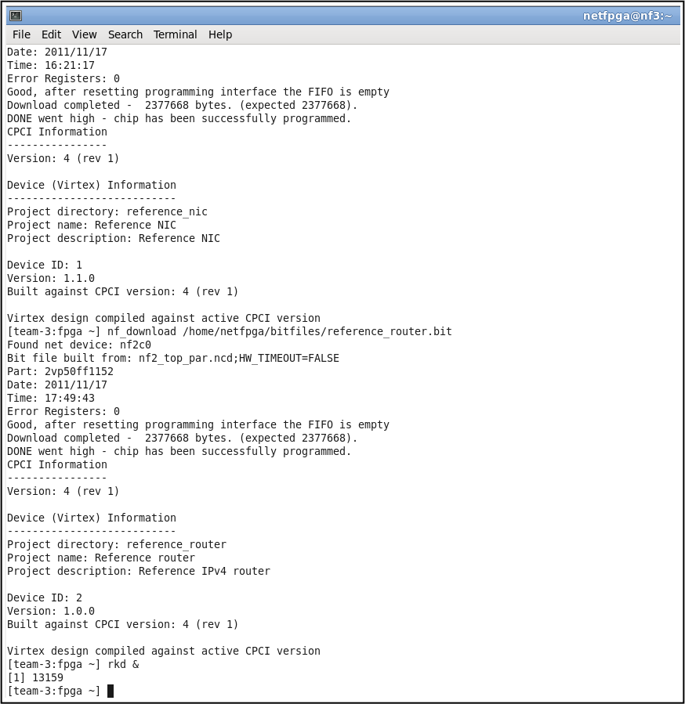

We then loaded the reference_router bitstream onto the fpga and ran “rkd &” to load all of the needed information from the Linux kernel into the routing table of the NetFPGA in order to accelerate the routing process.

1. Now re-run the iperf tests. Has the bandwidth changed? If so, why?

*ANS:* When we re-run the commands identify the acceleration. The measured bandwidth of the server was 354 MBits/sec. In comparison, this is way higher than the execution of ‘iperf’ when reference nic was loaded 77.8 MBits/sec

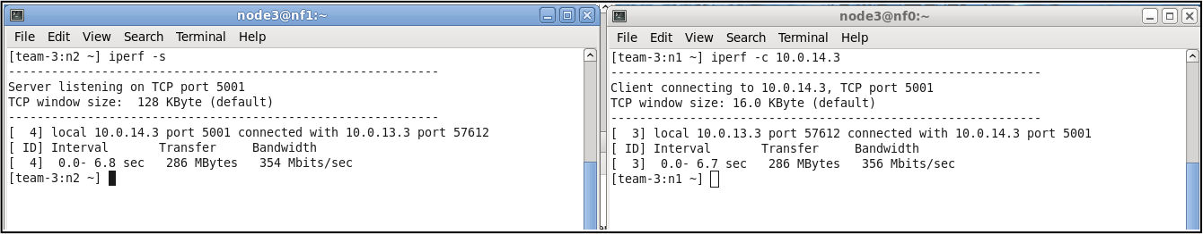

Now that we have the reference_router loaded, we re-run the ‘iperf’ commands to see the acceleration. In the snippet above, the bandwidth according to the server is 354 Mbits/sec. This is significantly higher than the execution of ‘iperf’ when reference_nic was loaded (77.8 Mbits/sec).

We then created two shell scripts on the fpga node, “udpclients_launch.sh” and “udpservers_launch.sh”. The server script iterates through a loop that SSHes to each node (n0-n3) to launch a UDP server on each of them. The client script iterates through a loop that SShes to each node and launches a client on each node. Each client that is launched will then connect to a server that is on a different node (i.e. client n3 → server n0, client n2 → server n1, etc.). Additionally, the client script specifies a bandwidth of 1G, a packet size of 512 bytes, and a test duration. Both scripts write the results into a separate log file, one for the results from the client’s side and one from the server’s side.

Using the reference_nic bitstream, here are the results after running the two scripts.

1. Make sure to run the test several times and take the average results. Look at the output of the servers to see how much performance you are able to attain. What is the total bandwidth you are able to observe through the NetFPGA? Why does using the small packets stress the system?

*ANS:* From the snippet below, we can see that 91% of the datagrams are lost. Additionally, the total bandwidth is 86.5 Mbits/sec (adding up the bandwidth of each client node). Small packets stress the system due to increased packet processing. This limits the throughput and results in packet loss as the system cannot keep up with the incoming data rate. Additionally, small packets might lead to more frequent use of network buffers, leading to packet loss if buffer overflow occurs,

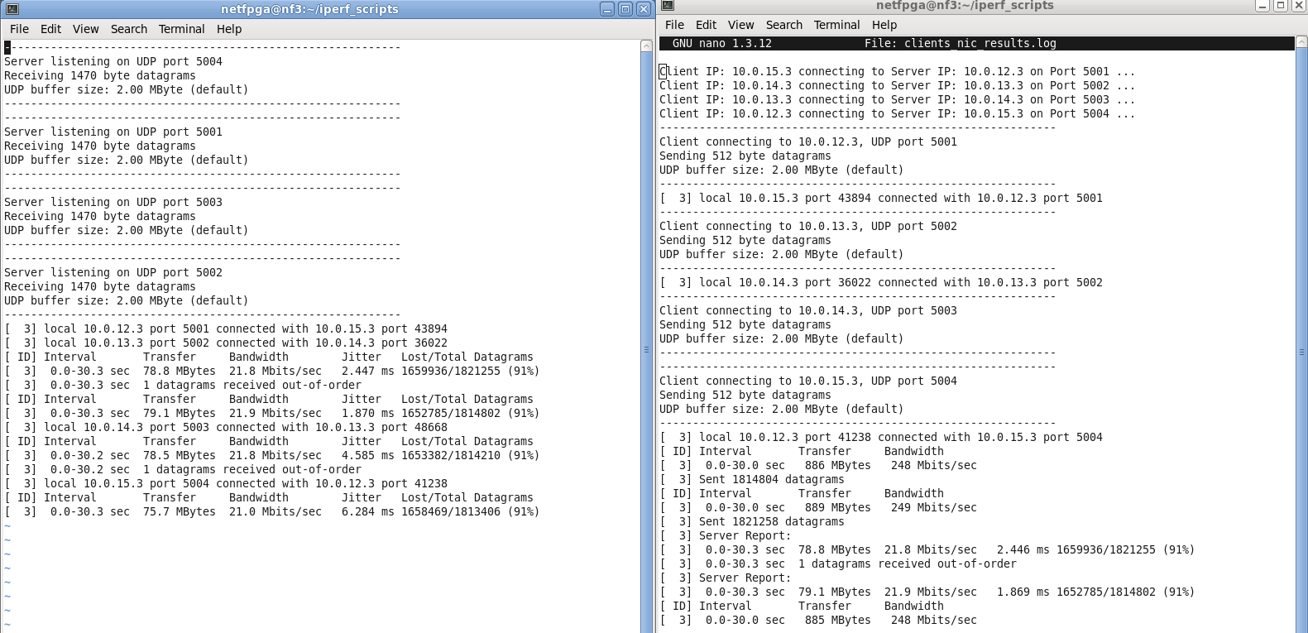

1. Load the reference router.bit file again and start the ‘rkd’ daemon. Run the same iperf. What do you observe? Is it fair to say that the NetFPGA can route IP traffic bi-directionally at line-speed for a total of 4Gbps of cross-wise bandwidth?

*ANS:* We then loaded the reference_router.bit file and ran the scripts again. Below are the output log files. We can see that there is less packet loss, but it is still bad with 83% packet loss. Additionally, the total bandwidth is 146.8 Mbps by adding all the bandwidths from the server output log. Hence, it is not fair to say that the NetFPGA can route IP traffic bi-directionally at line-speed for a total of 4Gbps of cross-wise bandwidth.

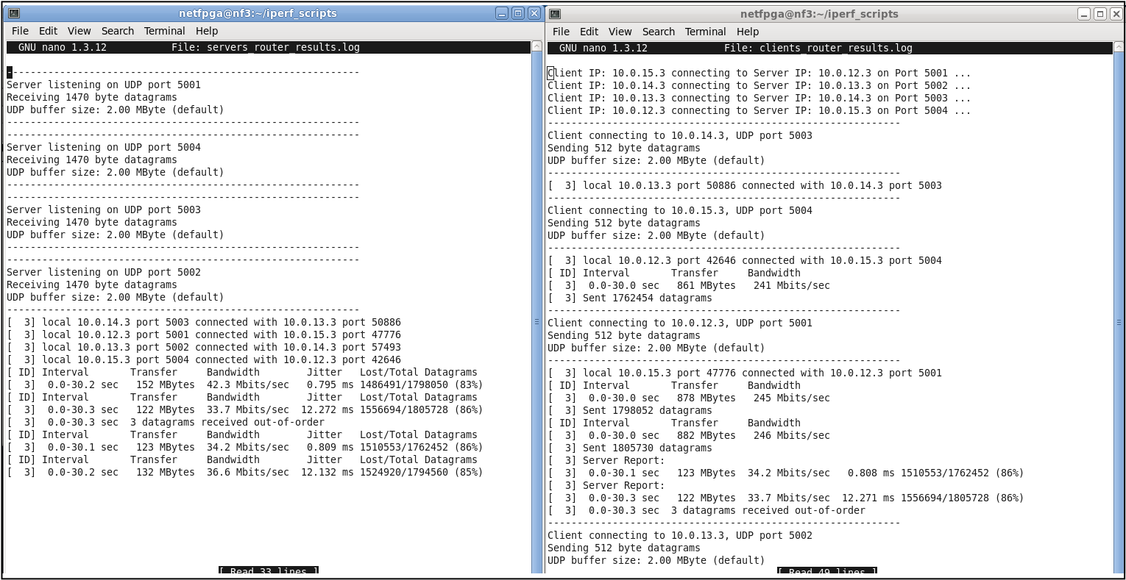

***Team GitHub: EE533-TEAM3/EE533_LAB_PROJECTS/ Commits & Changes***

